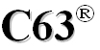
American National Standards Committee C63®
Electromagnetic Compatibility
Subcommittee 3: International Standardization

Chair: Ross Carlton Vice Chair: Ernesto Mendoza Secretary: Jerry Ramie
Webinar
May 10, 2023; 1:00 PM – 2:30 PM - EDT
Draft Meeting Agenda
1. Call to Order: Chair
1.1 Announcements: Chair's remarks –
1.2 Meeting logistics announcements: Host (N/A)
1.3 Introductions: Secretary – roll call (attending members with their affiliations and guests are recorded separately below) (note absences, excused absences and errors)
1.4 Present membership: Report any roster errors to the ASC-C63® Secretary

Subcommittee 3 Membership Roster. See errors, absences and excused absences below:
Mike Cibulka has left Rockwell without a forwarding address.
Name | Role within Subcommittee 3 | Affiliation
Abbondante, Nick | Liaison Member  US CISPR/A Technical Advisor | Intertek (Primary)
Carlton, Ross | Chair Subcommittee 3 | Gibbs & Cox (EMC Society Expert)
Coder, Jason | Chair Subcommittee 7 | NIST (Primary)
DeLisi, Bob | Chair Subcommittee 4 | UL LLC (Primary)
Fanning, Craig | Liaison Member  US CISPR/D Technical Advisor | Elite Electronic Engineering (Primary)
Griffin, Andy | Member  US CISPR/H Technical Advisor | CISCO Systems (Primary)
Hare, Ed | Chair Subcommittee 5 | ARRL (Primary)
Hodes, Harry | Member | Consultant
Hoolihan, Dan | Chair ASC-C63® | Hoolihan EMC Consulting
Klinger, Jeff | Member | Cetecom, Inc.
Kramer, Doug | Chair Subcommittee 6 | Apple Inc. (Technical Expert)
Mendoza, Ernesto | Vice Chair Subcommittee 3  US CISPR Technical Advisor  US CISPR/F Technical Advisor | Signify
Popovici, Horia | Member | Innovation, Science and Economic Development Canada (Alternate)
Potts, Nate | Member | Keysight Technologies (Primary)
Shellman, Marcus | Chair Subcommittee 2 | DOD – Joint Spectrum Center (JSC) (Primary)
Non-Voting Members
Arnett, Dave | Liaison Member  US CISPR/I Technical Advisor | Garmin
Cibulka, Michael | Liaison Member  TC77 & SC77B Technical Advisor | Rockwell Automation
Hofmann, H.R. (Bob) | Emeritus Member | Hofmann EMC Engineering
Jones, Steve | Liaison Member | FCC Laboratory
Mahn, Terry | Liaison Member  US CISPR/B Technical Advisor | Fish and Richardson
Pettit, Ghery | Liaison Member  CISPR/I Chair | Pettit EMC Consulting, LLC
Guests and Observers: (non-voting) Jerry Ramie,
1.5 Quorum: (50% of roster) constitutes a quorum. (rounding up) (15 roster members / 2 = 7.5 >> 8 (therefore 8 people are required for a quorum) Was quorum achieved? (Yes/No) If not, any actions taken are subject to confirmation by electronic ballot or at a future meeting. (Quorum is not required for Working Group meetings)
2. Approval of the Agenda: Secretary - Secretary will scroll through this agenda to show it and then ask for approval.
2.1 Approval of the previous Minutes - 20230222
2.2 Review of the patent slides –
3. Review of Subcommittee Membership, - Report any errors to the Secretary
3.1 Review of Membership Guidelines
Subcommittees:
For an individual to remain a voting member of a Subcommittee, active participation in Subcommittee meetings and regular responses to Subcommittee email votes is required. Should a member fail to attend at least one of three consecutive scheduled meetings (in person or remotely via web conference (when used)) or respond to at least one of every two consecutive Subcommittee email votes, their membership in that Subcommittee may be at risk.

Note: Abstentions shall be treated the same as a “yes” or “no” vote regarding the requirement to respond to email votes.

Member Attendance Log: Any errors in the log?
Any members at risk? None are at risk.
3.2 Consideration of new members? Application for C63® Subcommittee Membership

4. Status of harmonization projects - Chair
Status of harmonization of C63 documents with documents of other Standards Development Organizations (SDOs) is summarized in Table 1. Status is provided by the cognizant Subcommittee.
Table 1: ANSC-C63® Document Harmonization Summary
ANSC-C63® |  |  | Other SDO |  | Status
Document | SC | Subject | Document | Harmonization Goal

5. Other Old Business: Chair
5.1 Existing harmonization project reports - Written or verbal reports of the status of harmonization projects and needs for liaison support shall be presented by the responsible Subcommittee Chair. Written reports shall be made using either the C63_ PowerPoint template or the C63_PowerPoint_template_wide. Prior to the SC3 meeting, the SC report shall be provided to the projectionist for showing on the screen at the SC3 meeting.
5.2 Liaison needs – Identify needs and potential candidates for liaisons to facilitate harmonization projects. No new needs were identified at the last meeting.
5.3 Harmonization process – Discuss and develop harmonization processes and guidance for Subcommittees. Review the new changes to the process flow chart in Item 6.2 below.
5.4 C62.12 – This document will be allowed to expire in 2025 since the need for such a standard has been overcome by events.
6. New Business: Chair -
6.1 New harmonization projects – Discuss new harmonization projects for documents under development by the Subcommittees.
6.11 - C63.16 Guide to ESD Testing - Silberberg- harmonize with IEC 61000-4-2?
Discussion:
6.2 SC3 Scope, Duties and Tasks – There were no comments on the Scope at our last meeting. Only a Scope and Duties (Tasks) are required by our policy. As a result our new Scope, Work Flow, & General Tasks (Duties) are shown below for our approval.
Subcommittee 3 (SC3) is responsible for promoting and facilitating harmonization of C63 publications with those developed by national and international standards bodies. SC3 establishes and maintains liaisons with these standards bodies or the appropriate national committee to facilitate coordination and cooperation. SC3 is also responsible for writing and maintaining existing and proposed C63 standards as assigned by the Main Committee American National Standards Committee (ANSC) C63.
Work Flow:
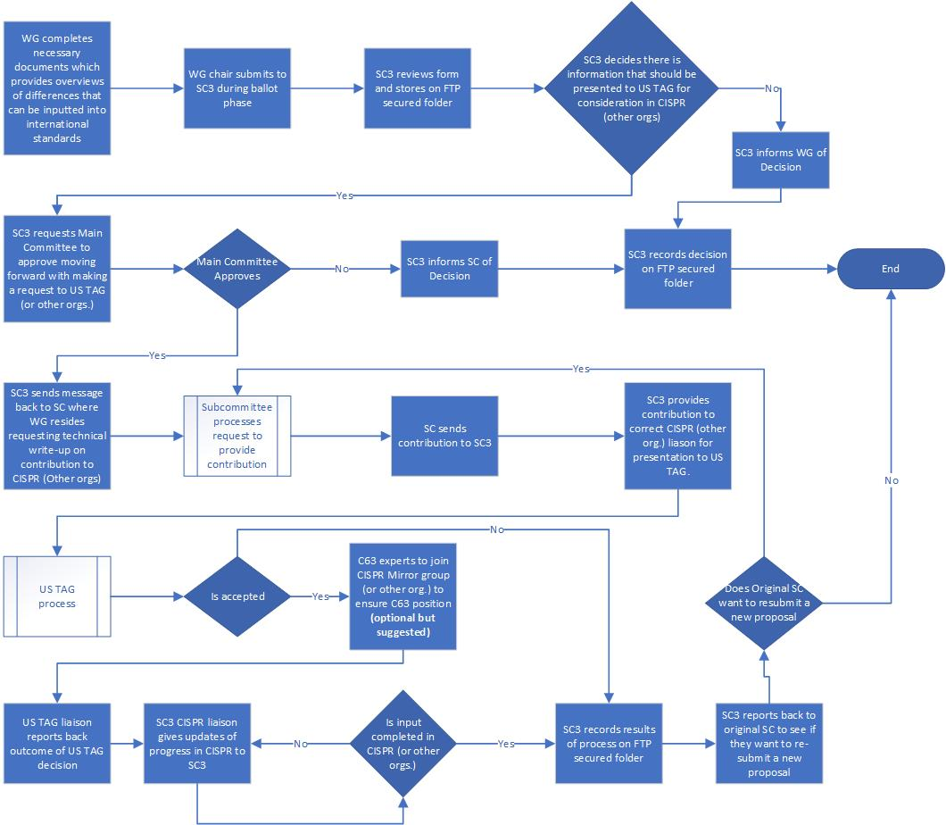
General Tasks:
1) For each PINS already in force or newly-prepared by C63® or its subcommittees, SC 3 shall prepare a statement on the relation of the proposed or existing standard to existing international standards or those in development.
2) When requested by the parent committee to review a specific C63® member standard, SC 3 shall prepare a statement on the relation of the proposed or existing member standard to existing international standards or those in development.
3) In cases where harmonization with an international standard is not considered appropriate, SC 3 shall summarize the differences in technological applications, government regulations, or practical considerations that justify differences between US standards and international standards.
4) SC 3 shall make recommendations to C63® regarding which international standards should be adopted directly as US national standards.
5) SC 3 may recommend to C63® that the standards work of C63® be used as input (via the liaisons with the USNC TAGs) to appropriate international standards for which the liaison members are responsible.
Membership Criteria
There are two classes of membership: regular members and liaison members.
Regular Members:
For regular membership consideration, applicants are required to attach a resume to the application form highlighting their expertise in electromagnetic compatibility and the type of contributions they can provide of interest to Subcommittee 3. Subcommittee membership requires Subcommittee approval and a C63® vote and, if approved, notice of acceptance will be sent to the applicant. For name and address of the Subcommittee Chair and for Subcommittee projects, please see the Subcommittee listings on the C63® web site at www.C63.org
See "Membership and Working Group Roster" page for additional criteria for continued membership
Liaison Members:
Liaison members are special non-voting members as by virtue of their positions may be needed to conduct SC3 business that covers topics of the standards committees which they represent. The liaison members of Subcommittee 3 consist of the technical advisors (TAs) and deputy technical advisors (DTAs) of the IEC USNC TAGs which have as their main scope EMC topics. These members are approved by the regular members of the subcommittee and the parent committee as noted for regular members. Should the need arise to include additional liaison members during the year (in addition to those included on the SC membership list approved at the first C63® meeting of the year) as a result of special circumstances (i.e., the individual can contribute significantly to the work of the Subcommittee), liaison membership may be granted after approval by the Regular Members of the Subcommittee and a parent committee vote. .
NOTE: Fees for membership, meetings, and other costs are covered in the general fee structure on the C63® web site. Liaison members will not have a regular membership fee but may be charged a meeting fee to offset meeting expenses.
Last Updated 12/01/2022
Motion to approve? -
6.3
7. C63.org website use and updates: Secretary - We normally post documents to the SC3 protected area. If any SC or WG needs help with this posting, a Technical Secretary is available to assist.
8. Review of the Action Items: Secretary
8.1 Review of Action Items from previous meeting:
Consolidated Action Items from 02/22/23 Meeting of SC3
AI # | Task | Responsible party | Due Date | Status
AI-156: | Jerry to add Doug Kramer to SC3 Webex list. (remove Randy Long) | Jerry Ramie | 5/10/23 | Closed  added 2/22
AI-157: | Ross to mark up the flow-chart and have Bob address the changes requested. Review at the next meeting. | Ross Carlton  Bob DeLisi | 5/10/23 | Closed  (JPG)
AI-158: | Jerry will delete the General Tasks above | Jerry Ramie  S Archambeault | 5/10/23 | Closed posting order sent 2/22; reminder sent 4/6

8.2 Review of Action Items from this meeting—Secretary -
9. Next meeting: Chair – TBD
10. Closing remarks and Adjournment: Chair
****************************************************** End of Meeting *****************************************************

